Form 102 Sampling for Broadacre Disease Diagnosis

Please follow these guidelines to ensure you send the most appropriate plant or soil samples for accurate and timely disease diagnosis.

* Take fresh samples, keep them cool and out of direct sunlight.
* Label sample bags clearly with a permanent marker.
* Submit affected and unaffected plants packaged and labelled separately (e.g. inside, outside and boundary of affected areas).
* Submit at least 10 whole plants, or 20 seedlings.
* Send samples as per instructions below.
* Avoid sending samples on a Thursday or Friday otherwise refrigerate until despatched the following week.
* Label the parcel ‘Urgent plant samples - keep cool’.
* Complete the Broadacre Plant Disease Diagnosis Submission Form.
* Complete a separate form for each species.

**Whole plant or root samples**

Pasture plants

* Collect as sod samples (20 x 20 cm), to 5-10 cm depth.
* Seal in a plastic bag, without removing the soil from the sample.

Crop plants

* Submit whole plants, unless it is clearly a leaf disease.
* Dig up plants so that the roots remain intact. Do not pull the plants from the soil.
* Leave the soil on the roots to keep the plants alive during transit. Washed roots will rot while in transit.
* Seal roots and soil in a plastic bag near the base of the plants. Enclose the whole sample inside another plastic bag (Figure 1).
* Enclose seedlings in one bag.

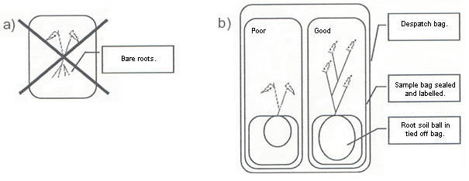

Figure 1 a) incorrect and   
b) correct sampling and packaging.

**Leaf samples**

Fungal / bacterial diseases

* Wrap cereal leaves in paper or enclose in a paper envelope. Do not send in plastic.
* Seal pulse or oilseed leaves in a plastic bag.

Viral diseases

* Collect new growth or whole shoots.
* Seal samples immediately in a plastic bag to prevent wilting.
* Package to avoid leaves getting squashed.

**Soil samples for detection of Nematodes, or Pleiochaeta spore counts**

Nematodes (moist soils) and Pleiochaeta spore counts

* Use a soil corer (e.g. pogo stick) to sample 0-10 cm (0-4").
* Remove surface debris in the area to be sampled.
* Sample soil for nematodes at 6-12 locations towards the margin of poor growth areas.
* Or collect 40 soil samples from wide paddock areas.
* Place in a bucket and mix thoroughly.
* Remove a 500g sample and seal in a plastic bag. Label the bag.

Free Delivery Instructions

Despatch samples in enclosed postal bag at any WA Post Office.

If not using the AGWEST Plant Laboratories despatch bag, address your sample to:

AGWEST Plant Laboratories  
Department of Agriculture and Food  
Reply Paid 83377

3 Baron-Hay Court  
South Perth WA 6151

This form is available on the APL home page [**agric.wa.gov.au/agwestplantlabs**](http://www.agric.wa.gov.au/agwestplantlabs)