Farm water questionnaire

For the WaterSmart Farms voucher program

Round 1 - Wheatbelt groundwater exploration
A research and development partnership project supporting Wheatbelt farmers to identify reliable on-farm groundwater sources by funding geophysical surveys and partnering with researchers to refine groundwater exploration methods.

Preparing to apply
All applications must be lodged via the SmartyGrants platform. You will be required to answer some identity questions and to upload a completed Farm water questionnaire, along with any additional supporting information.
In preparing to apply, you should:
- Complete and save the Farm water questionnaire on the following pages.
- Collate any supporting documents, maps and files, ready for upload.
- Submit your application via the SmartyGrants portal. See the grants webpage for details.

About the Farm water questionnaire
Providing information is more important than the format it is provided in.
The Farm water questionnaire is provided as a Word document to allow you the flexibility to include:
- explanatory text or data
- photos or screen snips (Figure 1)
- links to Google pins, for example https://maps.app.goo.gl/dENPLiUnx2ANcmVb8), or other mapping tools, such as the department’s GeoMap.
A farm plan can be as simple as marking relevant information on a printout and snapping a photo (Figure 2) or uploading digital files and data (if available).
If necessary, we will get back to you to discuss the data you have supplied, especially if your proposal progresses to the detailed assessment phase.

Contact us
Email: water.science@dpird.wa.gov.au

Examples
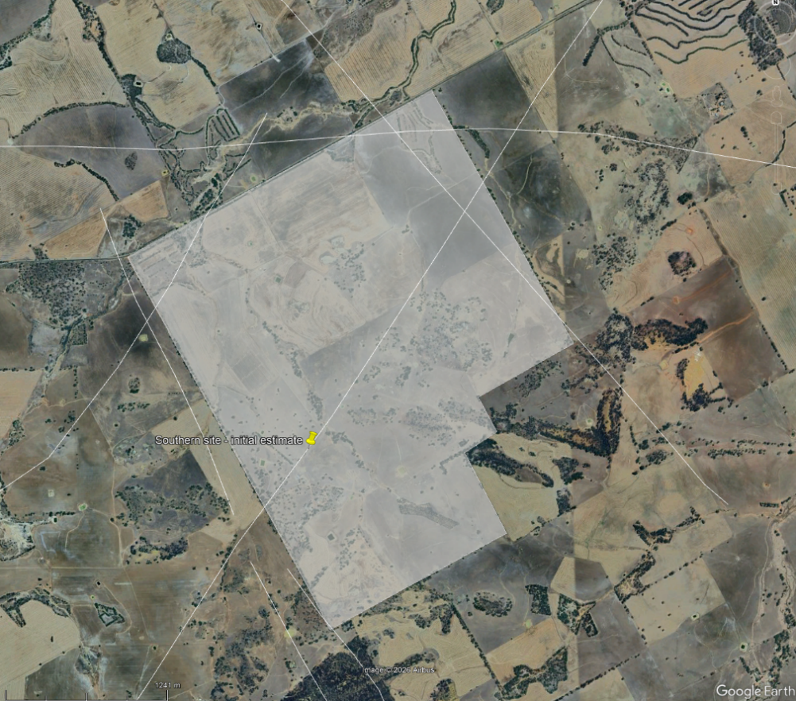
Figure 1. Example screen snip of a Google map with pin to mark a location on the farm.
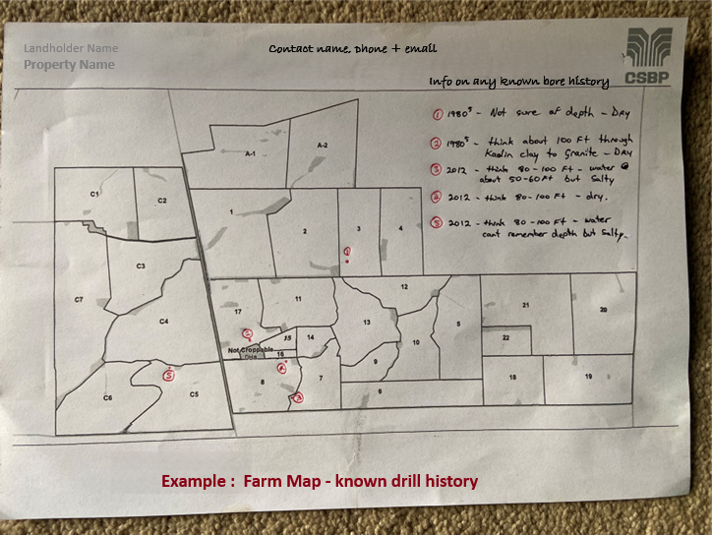
Figure 2. Example of a farm plan with known bore and drill history marked and details recorded.

Farm water questionnaire
If additional supporting documents (in addition to this completed questionnaire) are to be uploaded with an application, you may refer to these items in your responses rather than duplicate the information.

Contact and property identification
Use the DPIRD Agricultural Property Finder tool to locate your Property ID number.

DPIRD property ID number

Property name

Contact name

Phone number

Water planning

Water needs

Main uses of (non-potable) water
Rank 1 to 5 by priority. Add supporting information in the columns provided, where possible.
Rank | Use | Target Water Quality (salinity mg/L) | Current  volume used (kL/day) | Additional supply sought (kL/day)
 | Livestock
 | Spray Water
 | Irrigation (crop)
 | House (garden)
 | Other

Water needs – add information to demonstrate your need for additional bore water

Benefits and values (this question requires a response)
Describe the expected benefits and values to your business and your property, for example, productivity, landscape and water management). Where applicable, quantify in economic terms.

On-farm water sources and infrastructure
What do you have on farm now?
 | Current water infrastructure | How many do you have, size, supply etc?
☐ | Bores | Refer to Q8 and include a farm plan or map of locations.
☐ | Other exploration and/or drilling  (successful or unsuccessful) | Refer to Q8 and include a farm plan or map of locations.
☐ | Dams
☐ | Tanks
☐ | Water Corporation grid access
☐ | Desalination
☐ | Other water treatment or filtration
☐ | Other

Bores and other drilling
The research team will access available Government databases and related data.
Tell us more about your own bores, previous exploration and drill locations on the property (successful or unsuccessful). Anecdotal or verbal family history information about past activities may be useful.
Include (where possible) information such as:
- location and depth
- in use / not in use (and why)
- volumes pumped (per day) and water quality (salinity)
- type of use (sheep, crop, house etc).
Example answers:
- Site 1 on map - 2024 (Joe Blogs Drill Co), 90m bore, water at approx. 75m, WQ suitable for sheep (~8000 TDS), maybe 30kL/day. Can provide monitoring and driller data.
- Site 2 - 1990 drilled to approx. 100ft/30m, dry (location marked on Farm Plan)
- Site 3 - N/W corner of paddock 3, think about 50m drilled through clay to granite, had water initially but very salty then went dry (location marked on Farm Plan as #3)

Include locations (farm plan, map or Google pin links).

Landforms and geology
The research team will access available Government databases and related data.
Share any additional local knowledge relevant to groundwater exploration on your property. This might include showing areas of rock outcrops, deep sandplain, salinity, or other soil types, etc.
Include locations (farm plan, map or Google pin links).

Priority areas for exploration
Tell us if there are any areas of the property that you would like to exclude or prioritise for exploration geophysics and drill locations. Identify the reasons for your request, such as proximity to existing power, existing water infrastructure, old shallow hole that was successful, or you want to exclude, for example, protected bush, other areas due to lack of access etc.
Include locations (farm plan, map or Google pin links).

Important disclaimer
The Chief Executive Officer of the Department of Primary Industries and Regional Development and the State of Western Australia accept no liability whatsoever by reason of negligence or otherwise arising from the use or release of this information or any part of it.

Copyright © State of Western Australia (Department of Primary Industries and Regional Development) 2026

